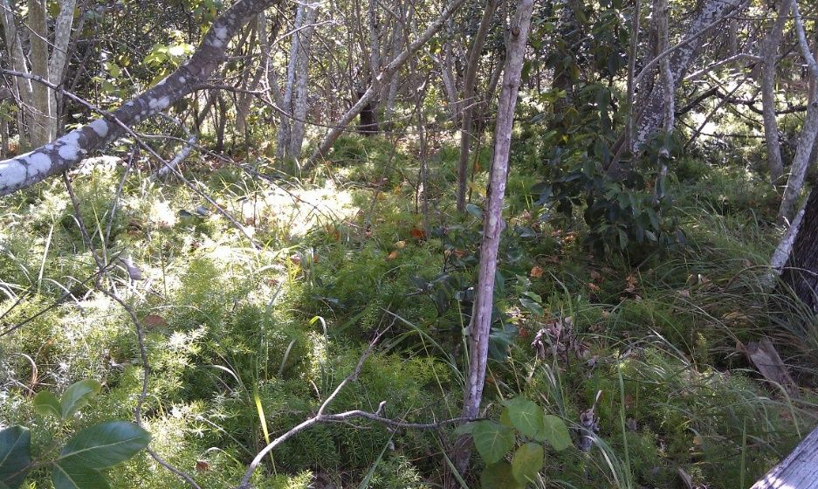
Peregian Creek, south of boardwalk, BA49, January 2016

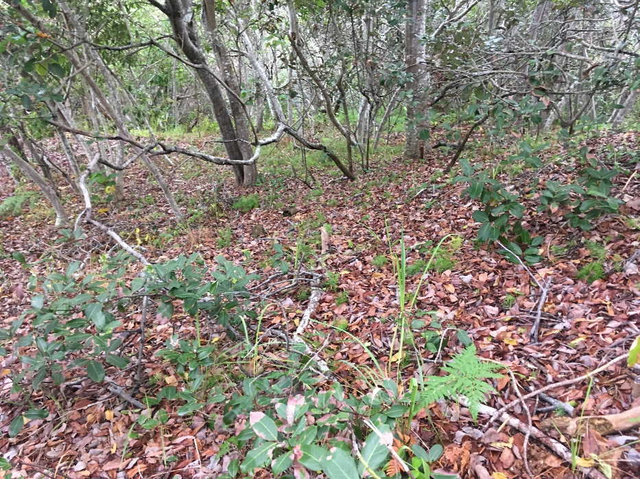
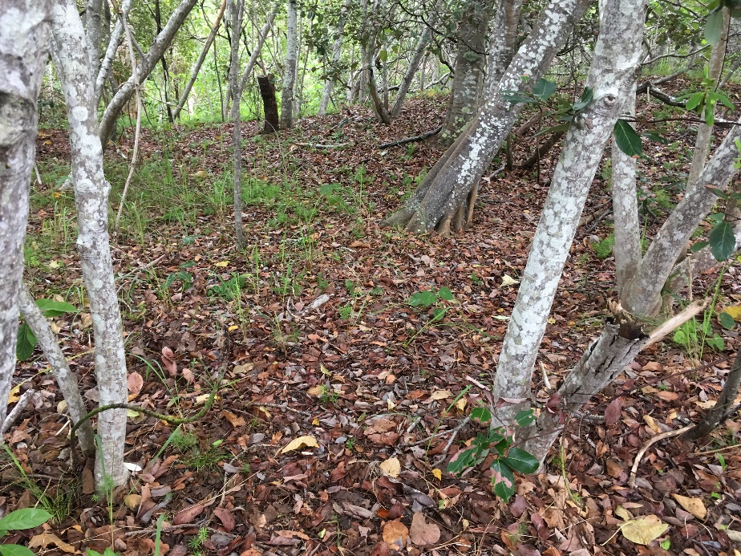
Peregian Creek, south of boardwalk, BA49, May 2019

